**Question Bank-CAT 2**

Q.1. Explain Reflection and Shearing Transformation with their Transformation equations and Matrices.

Q.2. Explain Cohen Sutherland Line clipping algorithm.

Q.3. Explain Sutherland Hodgeman Polygon Clipping Algo and discuss its advantages and disadvantages.

Q.4. Derive the matrix for Window to Viewport Transformation.

Q.5. Explain Curve Clipping and Text Clipping.

Q.6. Explain 3 D Transformations and its types. Also summarize their transformation matrices and equations.

Q.7. Explain in detail 3D Projection and its types with the help of neat diagrams. Write the differences between Perspective and Parallel Projection.

Q.8. Explain Viewing Pipeline.

Q.9. Explain and write differences between Bezier and B Spline Curve.

Q.10. Write short notes on Blobby Objects, Polygon Tables, 3 D Primitives, Polygon Meshes, Word Coordinates, Device Coordinates, Normalized Coordinates, Window, Viewport.

Numerical Examples:

1. Given a triangle with vertices (0,0), (2,0) and(1,1). Reflect this triangle about (a). x axis, (b). y axis (c). Line x=2 (d). y=1, and find the new vertices after reflection.
2. Given a triangle with vertices (0,0), (2,0) and(1,1). Shearing Factors Shx and Shy are 2 and 3 respectively. Apply 2D Shearing Transformation and find the new vertices of the square after shearing in-

a. x direction only.

b. y direction only.

c. x and y directions both.

1. 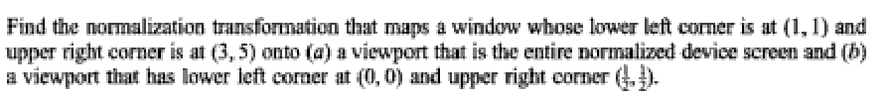



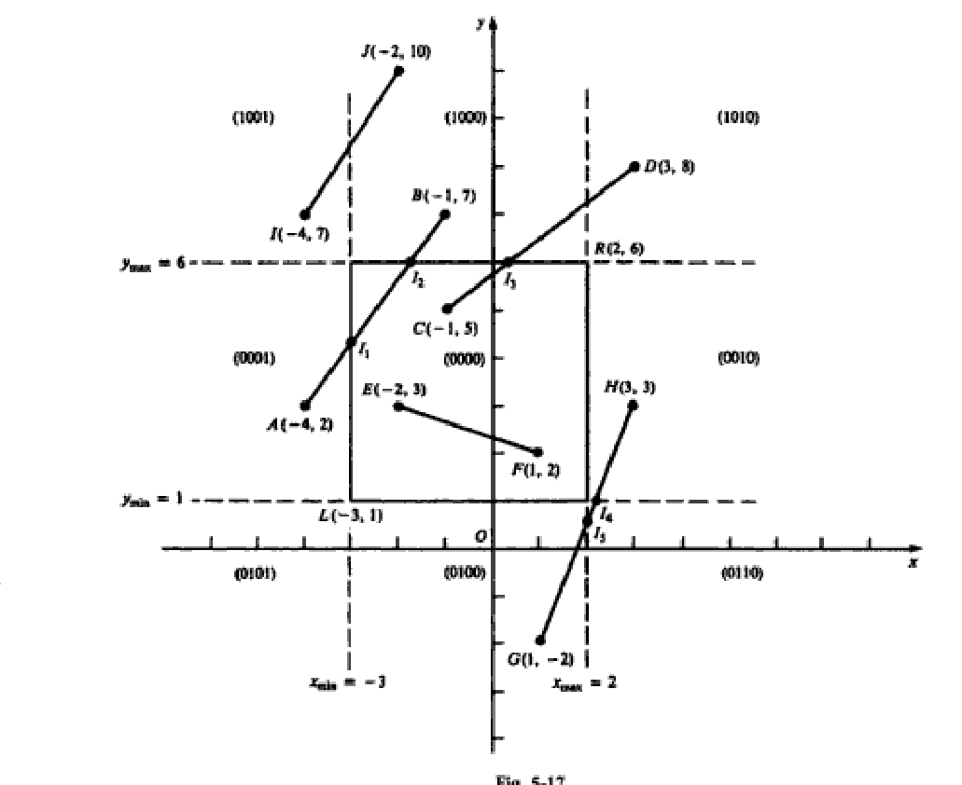

1. 
2. 

Apply Sutherland Hodgeman Polygon Clipping Algorithm to solve the Clip the polygon P1…………P8 against the window.

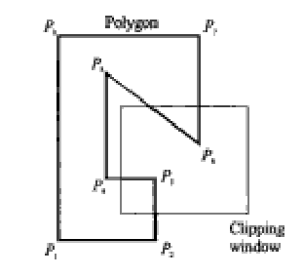

1. Apply Sutherland Hodgeman Polygon Clipping Algorithm to solve the Clip the polygon P1…………P9 against the window.

